How to cancel a booking
- Select ‘Bookings’ from the main menu
- Click the green ‘View’ button to the right of the relevant booking
- Click on ‘Amend date(s)’ tab
- On the new screen
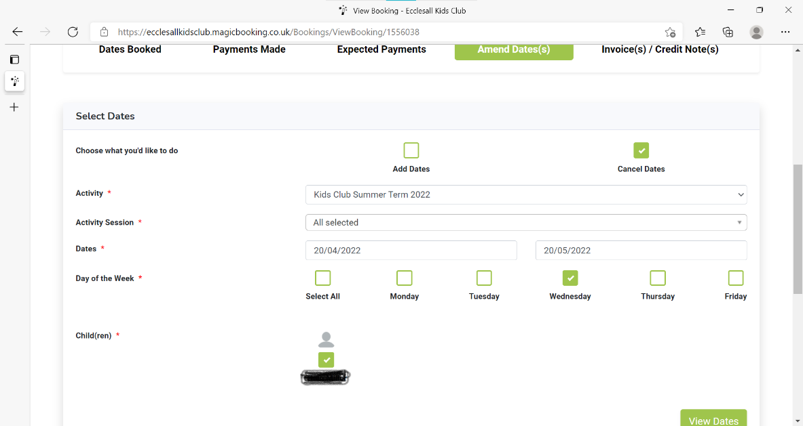
Fig.1
- Select ‘Cancel date(s)’
- ‘Activity’ Select appropriate booking from drop down menu ie. Kids Club 2024/25.
- ‘Activity sessions’ select the appropriate session from the drop-down menu i.e. Breakfast Club, Afterschool Club or All.
- ‘Dates’ – if you are cancelling sessions,
a). for just 1 day enter the date you want to cancel in both the ‘From’ and ‘To’ boxes ie From - 18:12:24, To – 18:12:24.
b). if you are wanting to cancel the same sessions over a number of weeks you need to insert the earliest date in the ‘From’ box and the latest date in the ‘To’ box as in fig.1.
c). If you wish to cancel odd sessions over a number of weeks you will need to use a mixture of a) and b) to achieve the appropriate result
- ‘Day of week’ Select the day(s) you wish to cancel
- ‘Child(ren)’ Select the child(ren) you wish to cancel sessions for.
- Click ‘View date(s)’
- On the next screen
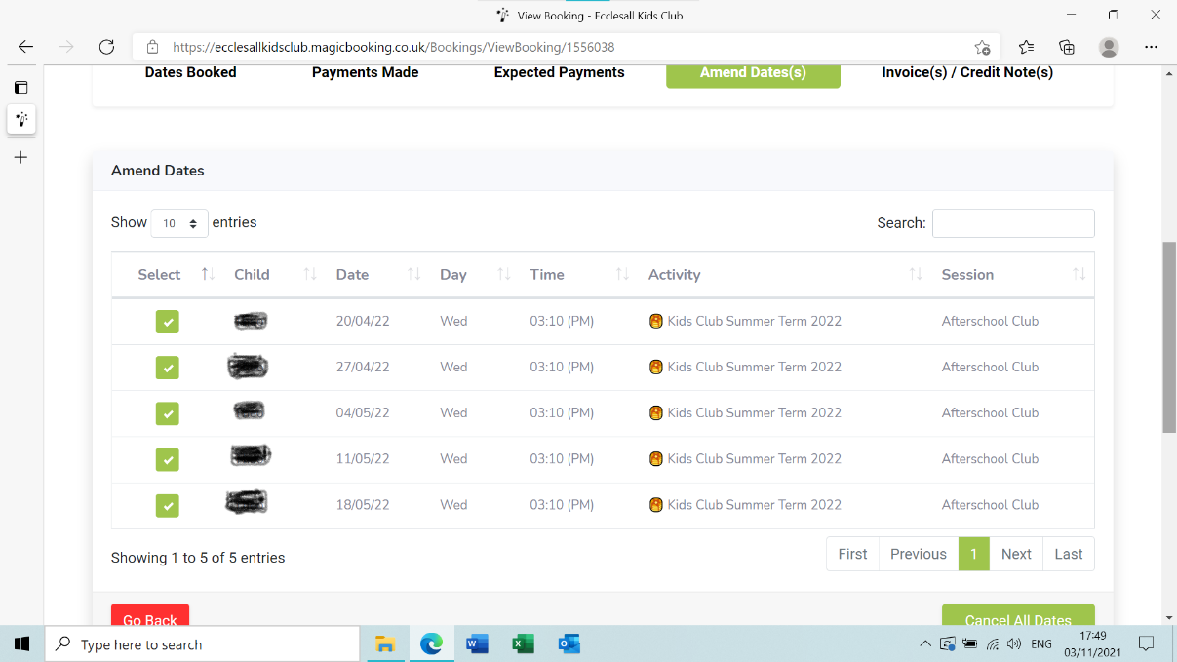
Fig. 2
- This page (Fig.2) will display all of the sessions you have selected to cancel. You may need to scroll through to see all of the sessions using the scroll buttons at the bottom of the page.
- You can ‘de-select’ any session that you have incorrectly selected by clicking on the green ‘select’ box alongside the incorrect entry.
- Any session that has a tick in the green box will be cancelled
- When you are happy with your selection click the green Cancel All Dates’ box at the bottom of the screen.
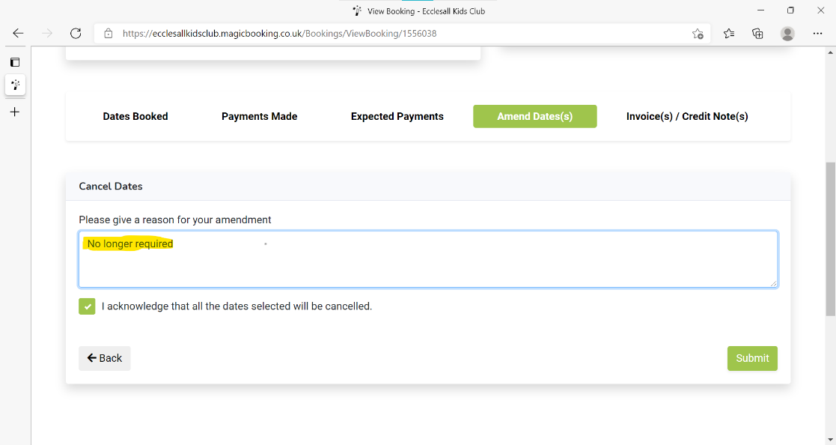Fig.3
- On the next screen (Fig.3) complete the reason for the cancellation. The system will prompt you to do this if you try to move on from this screen.
- Click the box to confirm that you agree to cancelling the session(s).
- Click the ‘Submit’ box
- A pop-up message will appear ‘Are you sure you want to cancel selected date(s)’
- Click ‘Yes’ if you are happy to proceed.
- A further pop-up message will appear ‘Your date(s) have been cancelled’ Click ‘Ok’.
- Please note that the sessions you’ve cancelled will still show in the ‘Dates booked’ section of the relevant booking, if you click on the ‘more’ button to the right of the session it should show the status as ‘cancelled’ in red.
Credits
- If you cancel a session more than 90 full days in advance of when the session starts you will receive a credit / not be charged for the session.
- If you haven’t paid off your booking in full, any credits will simply reduce your outstanding balance.

- If your booking is paid in full any credits awarded will show as a positive balance available to use against other / future bookings.
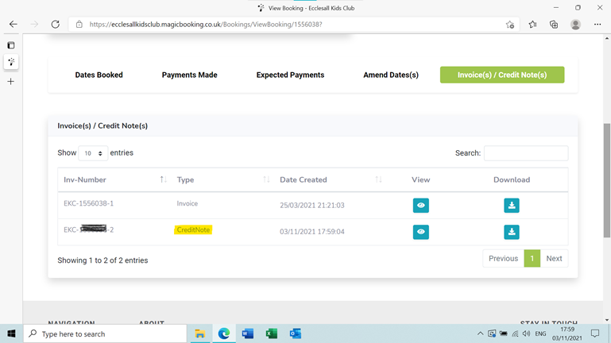
- You can view any credits awarded by selecting the ‘Invoice(s)/Credit note(s)’ tab on the relevant booking. This allows you to either view or download any invoices or credit notes relevant to the booking.

