**How to book**

Hopefully you’ll find the booking process reasonably simple, quick and self-explanatory.

To help below are some basic instructions on how to book. We recommend you use a computer or tablet to make your booking.

1. To make a booking login to your MagicBooking account at [https://ecclesallkidsclub.magicbooking.co.uk](https://ecclesallkidsclub.magicbooking.co.uk/) and follow the instructions below:
2. On the main screen select the activity you wish to book from the ‘Book an Activity’ box. This will either be ‘**Keystage 1 - 2024/25 Kids Club’ or ‘Keystage 2 - 2024/25 Kids Club’ for Kids Club or the appropriate Holiday Club activity.**A screenshot of a computer

   Description automatically generated
3. On the next screen click on the box below the name of the child(ren) you are booking sessions for.

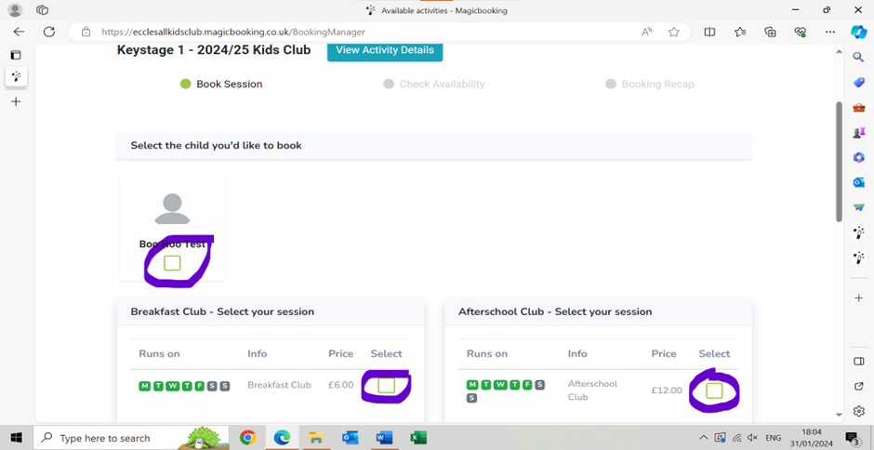

1. If you have more than one child registered in the **same keystage group** you can opt to book both/all children at the same time **if you want the same sessions for them**).

1. You then have the option of what sessions to book.    
     
   A screenshot of a computer

   Description automatically generated
2. If you want to book the same sessions each week throughout the term

* Click on the 'Breakfast Club' or ' Afterschool Club boxes (if you are booking both breakfast and afterschool club for the same days/dates then just click both 'breakfast' and 'afterschool' boxes at the outset if the system will allow)
* Select the days you want each week by clicking the appropriate box(es)
* Enter the date you want the sessions to start and end using the calendars. If you don't want to book the same sessions for the full term but still want consecutive weeks you can simply alter the start and end dates of your booking.
* Click on the green 'Add dates' button.

1. If you want to book ad hoc sessions

* Click on whichever session you require (Breakfast and/or Afterschool Club)
* Click on the 'Ad hoc' button
* Select a date from the calendar. It will appear in the ‘Selected date(s)’ box
* Continue to select dates until you have all the sessions you require.

1. When you have selected all of the ad hoc sessions you need click the green 'Add date(s)' button.
2. Check the ‘Added date(s)’ box to ensure that you have selected all of the sessions you need (either ad hoc and/or regular sessions). Once you are happy with the sessions selected click the green ‘Next’ button.  
     
   A screenshot of a computer

   Description automatically generated
3. If any sessions are unavailable, you will receive a pop up message (see fig below)

1. You can also check the availability of the sessions you’ve booked on the following screen which shows you the sessions you've booked week by week. Make sure that you **scroll through the tabs to ensure that all the sessions you have booked are available.  
     
   Graphical user interface, website

   Description automatically generated**
2. The ‘week’ tabs will display either as

* **‘Green’** all ofthe session you’ve requested that week are available.
* **‘Yellow’** means that **some sessions** you’ve requested that week **are not available**. The reason the sessions isn’t available will be shown under the ‘status’ column. For example, fully booked no places available, closed (school holiday), already booked (the system won't allow you to book the same session twice and it will show the booking reference number for where the sessions have already been booked)
* **‘Red’** means that **none of the sessions** you’ve requested that week **are available**.

1. Once you’ve checked availability click the green ‘Next’ button.
2. The next screen will show you the total number of sessions you've booked and the total cost.

1. If you wish to book sessions on another activity you have the option of clicking the green ‘Add another activity’ button the system will then take you back to the choose activity screen and you can repeat the process for another child and/ or activity.
2. When you have made all the bookings you require and you are back at the total cost screen you have a number of options of how to pay for your booking

**How to Pay**

No payments are required at this stage **however,** you do need to indicate how you intend to pay for the booking if it is approved otherwise the system will automatically cancel your booking.

1: I want to pay using a payment plan

* If your booking spans more than 8 weeks and meets the minimum amount threshold (this is a system calculated algorithm) you will be offered the option of paying using a payment plan.
* Click on the green ‘Pay Monthly’ box to take up this offer.
* You then have the option of paying by ‘Childcare vouchers/Tax-Free Childcare (TFC)’ or ‘Card’. Please check the box of which option applies.

**

* Select your provider (or “multiple” or “not listed”) from the drop-down menu and,  
    
  **Graphical user interface, text, application

  Description automatically generated**
* Enter the amount you want to pay each month by voucher. (You must enter the amount in pounds and pence). If you are paying the full amount by vouchers or TFC simple divide the total cost by 11 to get your monthly amount.
* Your ‘instalment start’ month should be **no later than August 2023**
* Click the green ‘next’ button  
    
  A screenshot of a computer

  Description automatically generated
* A pop-up box will display your chosen payment plan. If you are happy with the plan click ‘next’ or if you wish to change it click ‘back’ and re-input the details.
* When you are happy with the payment plan and you are back at the main page details tick the ‘Terms and Conditions’ box and click the green ‘Submit’ button.

**b: You’ve opted to pay by card  
  
**

* In the pop-up box enter the date in the month that you wish your card payment to be taken and click ‘Next’.
* The system will display the proposed payment plan. If you are happy with the proposed plan click ‘Next’.  
    
  A screenshot of a computer

  Description automatically generated
* After clicking ‘Next’ you should now be back at the final page. The system will display your chosen payment plan. If you decide you are unhappy with the displayed plan click ‘Delete Plan’. If you delete the plan you can now input a new plan or opt to pay outright.

* If you are happy with the details tick the ‘Terms and Conditions’ box and click the green ‘Submit’ button.

**c) I want to make a one off childcare voucher or tax-free childcare payment**

* On the final screen click the ‘Pay by one off childcare voucher/TFC’ box   
    
  A screenshot of a computer

  Description automatically generated
* Select your childcare provider (or “multiple” or “not listed”) from the drop-down list.
* Enter the amount to be paid by childcare voucher/TFC in the ‘Amount’ box and then click ‘Apply’  
    
  A screenshot of a computer

  Description automatically generated
* If you do not enter the full amount due, you will need to input an additional means of payment for the balance i.e. card payment.
* Click the ‘Terms and Conditions’ box.
* Click the green ‘Submit’ button

**What happens next?**

1. You will see a pop-up message on the screen informing you that your booking has been successfully completed. **Please note that this simply confirms that we've received your booking it does not mean that those places are secured as all bookings are 'subject to approval'.**  You will also receive a confirmatory email stating that your booking has been received and submitted to the centre manager for approval.
2. All places will be allocated based on the priorities shown in our booking policy. You will be notified within 7 days as to whether your booking has been successful. If we aren't able to accommodate your request, we will advise you of what options are available i.e. alternative days or waiting list.

Any problems please email us at ecclesallkids@gmail.com